## **Table 3.7**

|  |  |  |  |  |  |  |  |  |  |  |  |  |  |  |  |  |  |  |  |  |  |  |  |  |  |
| --- | --- | --- | --- | --- | --- | --- | --- | --- | --- | --- | --- | --- | --- | --- | --- | --- | --- | --- | --- | --- | --- | --- | --- | --- | --- |
| **25 Seeds- Group A** Concentration 25% Seeds 25  Date Began Testing: January/21/2002 | | | | | | | | | | | | | | | | | | | | | | | | | |
| Dish | A-1 | | | | | A-2 | | | | | A-3 | | | | | A-4 | | | | | A-5 | | | | |
| Day | 5 | 7 | 9 | 11 | 13 | 5 | 7 | 9 | 11 | 13 | 5 | 7 | 9 | 11 | 13 | 5 | 7 | 9 | 11 | 13 | 5 | 7 | 9 | 11 | 13 |
| CL |  |  |  |  |  |  |  |  |  |  |  |  |  |  |  |  |  |  |  |  |  |  |  |  |  |
| AH | 2.1 | 2.8 | 3 | 3.1 | 3.2 | 2.0 | 2.7 | 3.1 | 3.3 | 3.5 | 2.2 | 2.6 | 3 | 3.2 | 3.6 | 1.7 | 2.8 | 2.9 | 3.0 | 3.4 | 2.5 | 2.6 | 2.8 | 3 | 3 |
| RL | x | x | .1 | .3 | .5 | x | x | x | .4 | .5 | x | x | .3 | .5 | 1 | x | x | x | x | .5 | x | x | .3 | .5 | .6 |

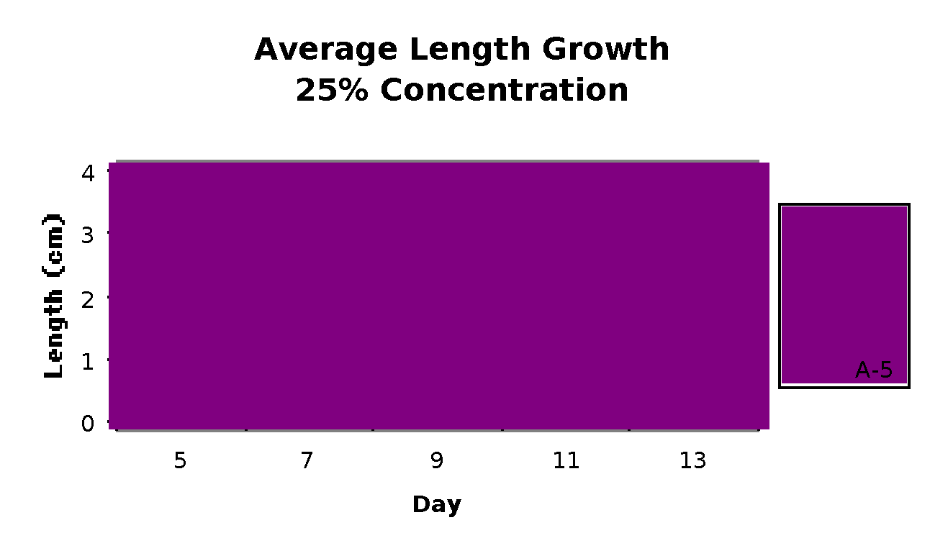

Figure 3.9